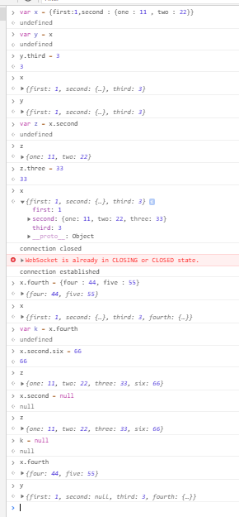

The above ss tells the object behavior in js , the behavior is same for linked list also. See the attached screen shot below

